
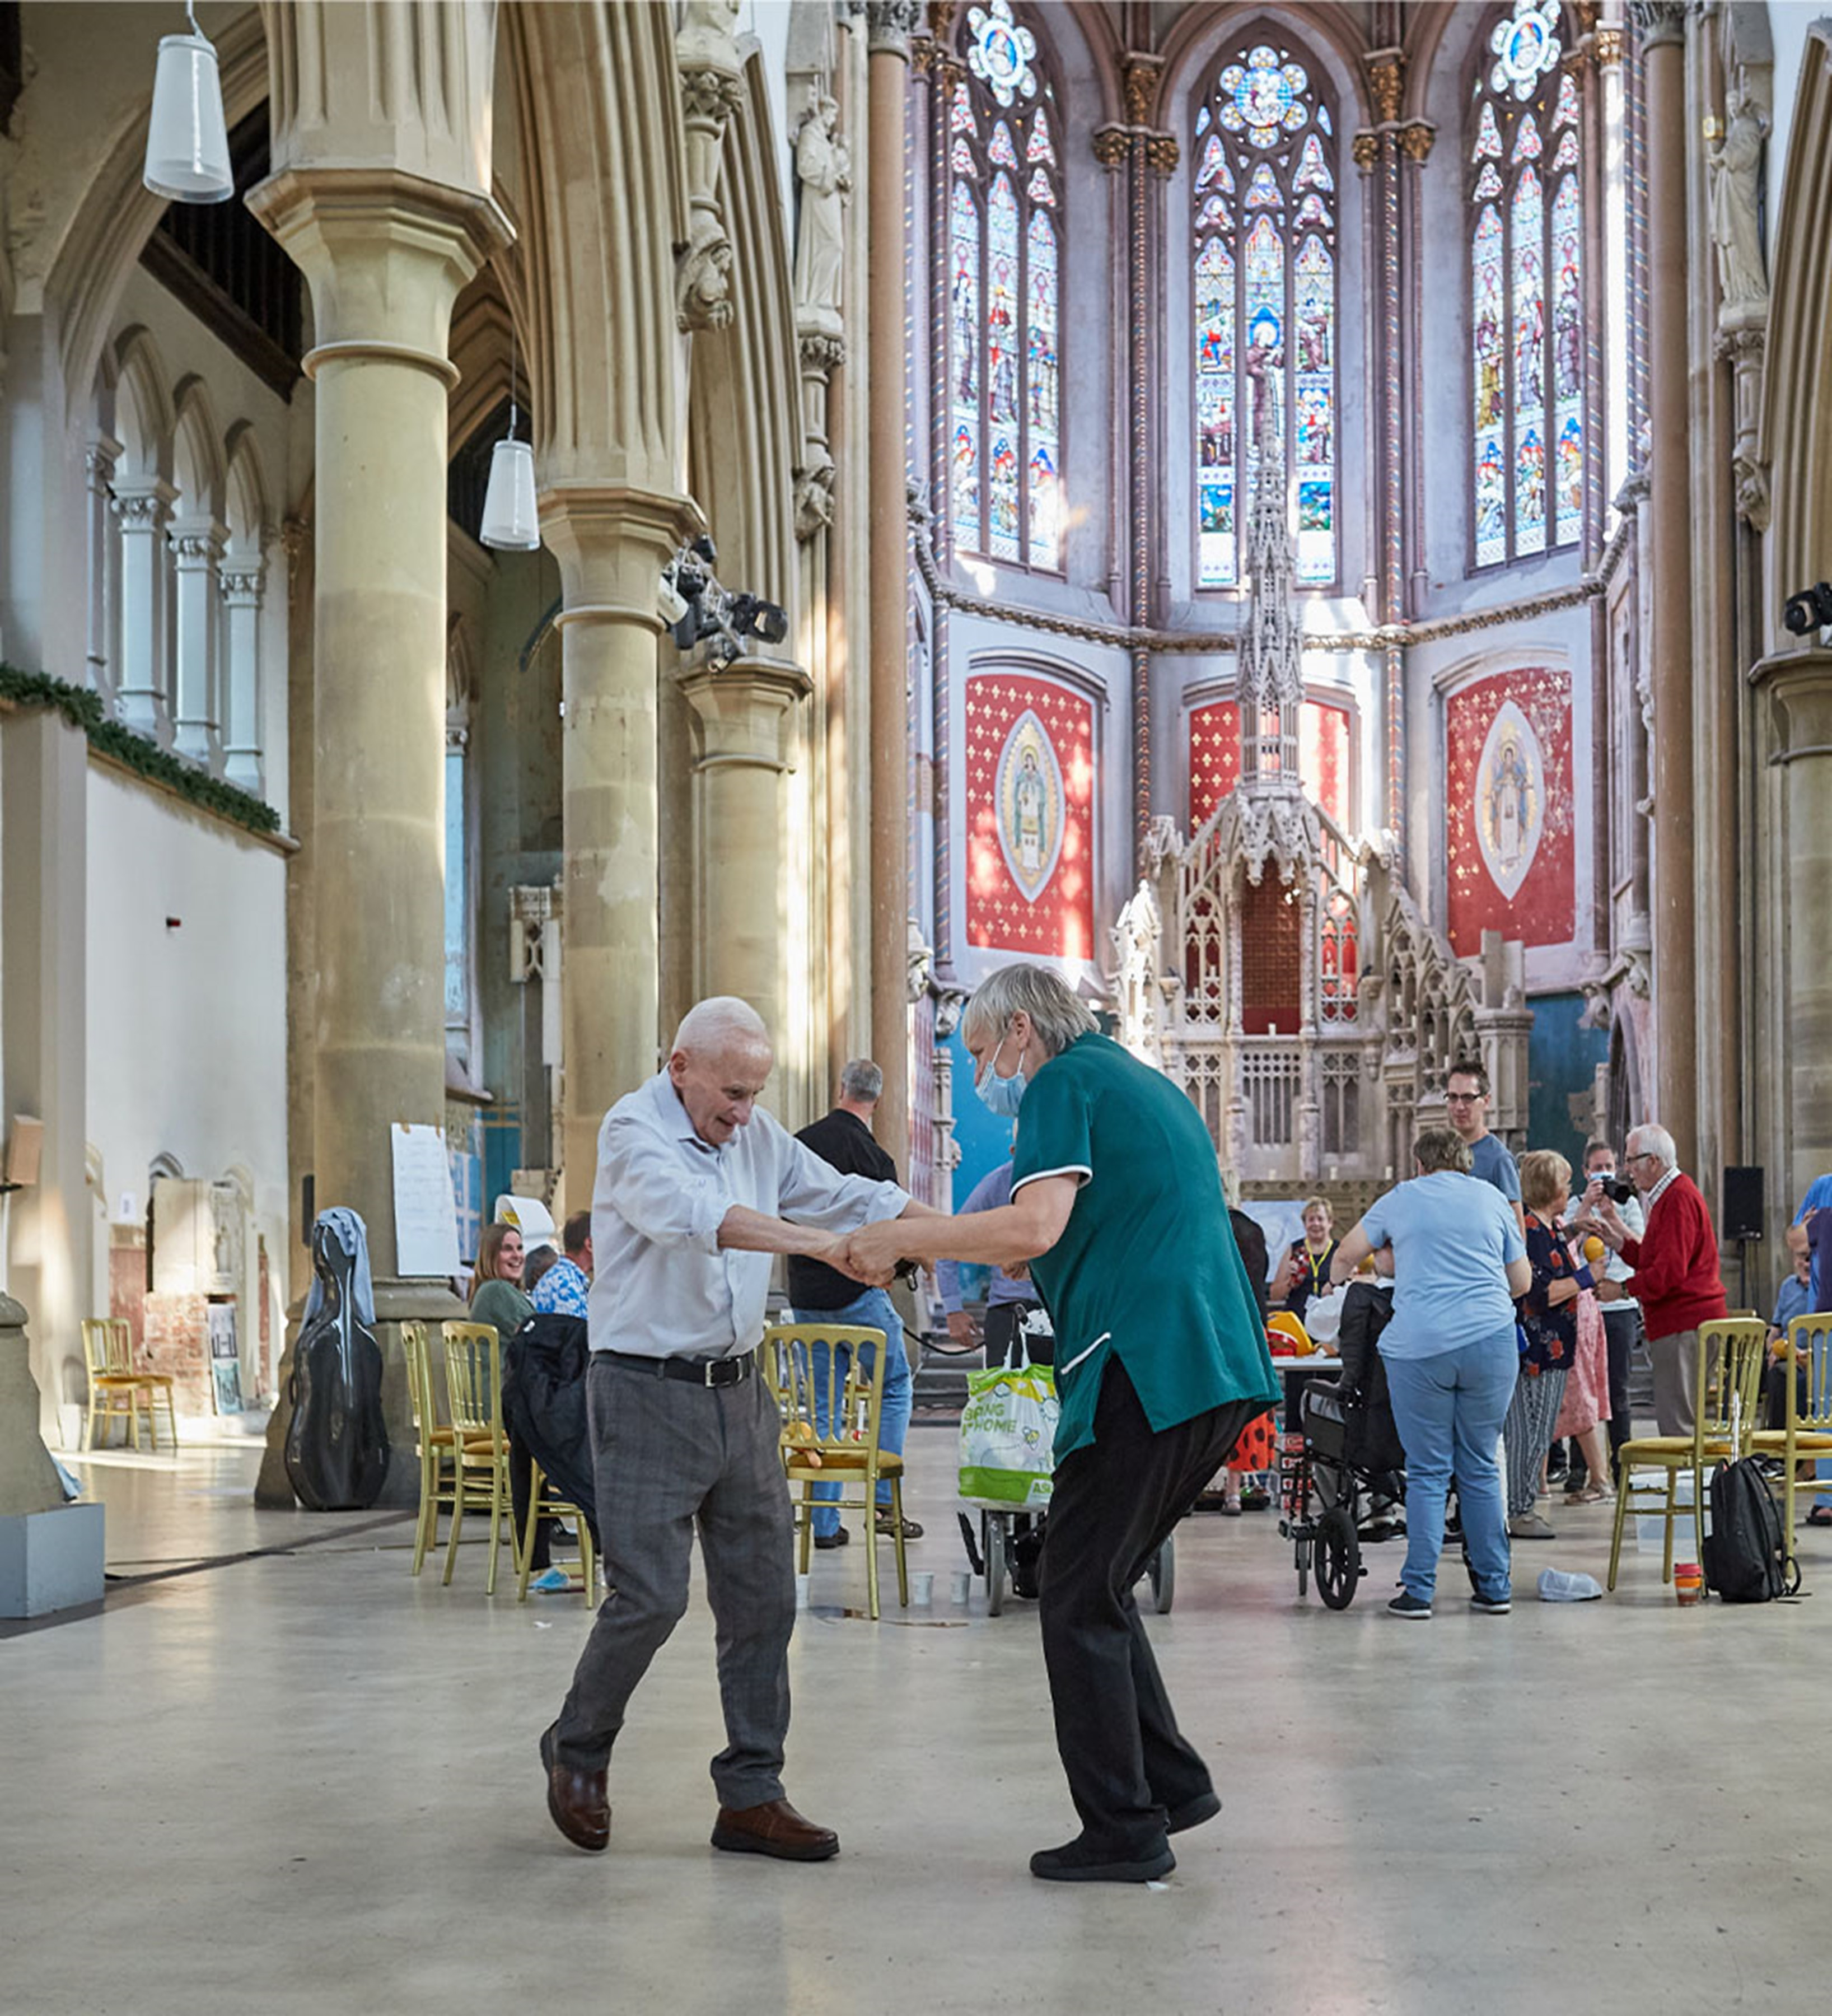

Head of COmmunity

Manchester Camerata Job Description - November 2023
Manchester Camerata – Recruitment
Manchester Camerata

Manchester Camerata is the UK’s most relentlessly pioneering orchestra. Our vision is for everyone’s life to be elevated and enhanced by exceptional music. Our purpose is to make music that matters; music for change. This is who we are. This is what we do.

Through our music and our impact, we change the lives of people and the prospects of places, not just through our actions, but also in the way that we work.

Be it opening Glastonbury festival in front of 40,000 people or working intimately in care homes with people living with dementia, we believe in the transformative and connecting nature of music. That connection drives us, and we work with the best creative talent to make this happen.

At Manchester Camerata, we want every person affected by dementia and every young person in Greater Manchester to have access to the benefits of world-class music-making. For over a decade we have developed sector-leading community programmes, which has informed our ambitious Social Impact Plan for Greater Manchester.

The Social Impact Plan prioritises consultation and collaboration with communities to create needs-driven, life-changing impact throughout all 10 boroughs of Greater Manchester over the next 10 years. Through external research studies and internal evaluations, we aim to demonstrate nationally and internationally the health and wellbeing benefits of our community work.

Who We’re Looking For

We’re looking for someone who will lead the delivery and development of our exceptional Community programme. You would enjoy bringing creative energy, independent thinking, leadership, and business know how. You would identify with our culture and recognise ways in which you could develop and contribute to it.

You will have the practical skills of managing medium/large-sized budgets and planning complex projects in collaboration with the whole Camerata team and external partners to bring about ‘music for change’.

You will bring empathy and compassion; original thought to create bold new approaches; a drive to achieve excellence in our work; and be unafraid to take risks.

A natural collaborator, you will work across the team as well as our professional musicians, music therapists, external practitioners, local and national partners, and funders to achieve the organisation’s long-term aims in arts & health and cultural education.

Employment Terms
Job Title: Head of Community, Manchester Camerata
Reports to: CEO, Manchester Camerata
Salary: £34k-£38k depending on experience
Contract: Full-time permanent (35 hours/week) including some weekend and evening work, and international travel. Flexible/hybrid work possible.
Holiday: 25 days per annum (Jan-Dec) on an accrual basis
Office base: The Monastery, 89 Gorton Lane, M12 5WF

Community programme strategy

We have three core areas of activity which are underpinned by a research strand:

- Music in Mind is our pioneering music and dementia programme for people in care home and their carers’ and families. Developed over 12 years in partnership with The University of Manchester, we work with our specially-trained musicians and music therapists to provide ‘in the moment’ music-making sessions, helping to bring about the benefits of music that our research has proven. Recent developments include the formation of:
- Free Music Cafés for people living with dementia and family carers still living at home. Music Cafes are run on our Music in Mind music therapy principles and provide respite for home-carers and help decrease levels of social isolation.
- Formation of a fledgling and linked business (Music in Mind Remote Ltd), in collaboration with UK Research and Innovation and the NHS. It has developed a ‘Music Champions’ scheme for carers around Greater Manchester and the North, which begins a scale up phase in 2024.

- Create with Camerata is our work in schools. Our musicians, theatre makers and composers help school children write their own songs about subjects in the general curriculum, in turn helping them improve their social skills (increased confidence) and introducing them to high-quality music-making. We also provide teachers with musical classroom activities to use while we’re not there, keeping a legacy of music-making in everyday school life.

- The Social Impact Plan is steered by a process of consultation, to find collaborations and creative projects which respond to what communities want and need. In part, this was a response to the Greater Manchester Inequalities Commission report in 2021, our work over 8 years in the East Riding with close partners – Orchestras Live, and decades of work in the North of England, in this arena.

Our staged plan has a proof of concept in Gorton, Manchester, and developing relationships and programmes in other areas of Greater Manchester. It’s ready to develop further, at pace. We draw on all the elements of the above programme, and where possible collaborate to make something like this The People Make the Place.

Many of these projects create an evidence base for our academic research partnership with The University of Manchester, which helps demonstrate outcomes and impact of our Community programme to culture and healthcare leaders, nationally and internationally. You’ll work closely with University colleagues to drive new research studies and help think of ways to develop our Community programme in collaboration with academic institutions and thinkers.

Key Responsibilities

  - Devise an innovative community music-making programme as per MC’s strategic plan, which means you:
- Work closely with Camerata’s CEO & Management team and key partners in developing all aspects of the programme.
- Ensure that you hold current and relevant information locally, regionally and nationally relating to arts & health, cultural education, and also funding streams.

- Oversee the delivery of all Community projects, providing effective line management to Community staff and practitioners, which means you:
- Are responsible for all elements of forward planning and delivery, including evaluation of activity and data collection.
- Provide effective line management to Community staff and practitioners, and support their development needs.
- Develop training programmes for musicians, teachers and care staff.
- Oversee Camerata’s safeguarding policy, implementing training and DBS checks.

- Create and deliver the annual Community income & expenditure budget. To achieve current budget targets, you will:
- Secure contracts for Community activity locally, regionally, and nationally
- Collaborate closely with the fundraising team to provide the content detail for an agreed schedule of trust and foundation applications and reports.
- Ensure concise and timely budgeting and invoice payments to service providers and musicians; ensure up to date budgeting and reforecasting for the Management Accounts & Board reporting.

- Develop key collaborative partners in arts, education and health and social care, which means you will:
- Work closely with the CEO and team at Music in Mind Remote Ltd, the member musicians and external practitioners.
- Maintain and develop relationships with existing and potential key collaborative partners (arts / health / higher education) regionally, nationally and internationally.

- To establish and maintain open and clear communication with the whole Camerata team and to actively encourage their involvement and collaboration with the Community programme for the benefit of the organisation.
- Liaise regularly with the Creative Director to ensure Community programmes of work align closely with concerts season where possible.
- Liaise regularly with the Fundraising and Communications teams to identify fundraising and profile opportunities.
- Oversee Camerata’s placements with students in Higher Education, liaising with colleagues in Concerts and Marketing departments.

Skills and Experience
Skills & experience

- Strategic thinker who can guide external partnerships through consultation to implementation and evaluation.
- Several years relevant experience within arts & culture, health or education spheres
- Managing a team of people to deliver complex projects, working with paid staff members, colleagues, freelancers, and external partners. Exceptional communications and organisational skills.
- Ability to negotiate effectively at the highest level.
- Creative, practical and able to deliver on challenging financial targets.
- High level of computer literacy including word processing, spreadsheets, web, experience of databases

How to Apply

If you’ve got this far, we’d love you to apply!

If you think it could be for you but feel uncertain about anything, or just want to find out more about what’s in this document we’d like to offer you some time to find out more. Contact the CEO Bob Riley on briley@manchestercamerata.com.

From there onwards, here are the details.

- A one-page letter that tells us about you, why you’ll be great at the role and what you’ll add to our culture.

- A CV (max 2 pages)

- Deadline for applications midnight Sunday 3rd December 2023.

- Interview Monday 11th December in person at The Monastery, Gorton Lane, Manchester, M12 5WF.

After applying, all applicants will be sent a survey link to help us gather equal opportunities data, which will inform Manchester Camerata’s organisational development regarding its Diversity and Inclusion policy and objectives. Please let us know if you have any additional requirements that will help you with your application.

